**Introduction to Unix Operating System :**

Unix and Unix-like operating systems are a family of computer operating systems that are derived from the original Unix System from Bell Labs.

Initial proprietary derivatives included the HP-UX and the SunOS systems. However, growing incompatibility between these systems led to the creation of interoperability standards like POSIX. Modern POSIX systems include Linux, its variants, and Mac OS.

Unix is the most powerful and popular multi-user and multi-tasking Operating System. The basic concepts of Unix were originated in the Multics project of 1969. The Multics system was intended as a time-sharing system that would allow multiple users to simultaneously access a mainframe computer.

Unix operating system features:

* It is a multi-user system where the same resources can be shared by different users.
* It provides multi-tasking, where each user can execute many processes at same time.
* It was the first operating system that was written in a high-level language (C Language). This made it easy to port to other machines with minimum adaptations.
* It provides a hierarchical file structure which allows easier access and maintenance of data.
* Unix has built-in networking functions so that different users can easily interchange information.
* Unix functionality can be extended through user programs built on a standard programming interface.

Introduction to Linux OS:

Linux:

* Linux is an operating system or a kernel.
* It comes under an open source license.
* **Linux is one of the most popular and widely used Kernel.**

Advantages of linux?

Open Source

One of the main advantages of Linux is that it is an open source operating system i.e. its source code is easily available for everyone. Anyone capable of coding can contribute, modify, enhance and distribute the code to anyone and for any purpose.

Security

Linux is more secure as compare to any other operating system. Every program in Linux whether an application or a virus needs authorization from the administrator in the form of a password. Unless the password is typed virus won’t execute. There is no requirement of any anti-virus program in Linux.

Software update

In Linux you encounter a larger number of software updates. These software updates are much faster than updates in any other operating system. Updates in Linux can be done easily without facing any major issue or concern.

Performance

Linux provides high performance on various networks and workstations. It allows a large number of users to work simultaneously and handles them efficiently.

Compatibility

Linux runs or executes all possible file formats and is compatible with a large number of file formats.

Fast and easy to install

Linux can be easily installed from the web and does not require any prerequisites as it can run on any hardware, even on your oldest systems.

Proper use of hard disk

Linux performs all the tasks efficiently even after the hard disk is almost full. This increases the performance of the Linux hence Linux provides high performance also.

Difference b/w Windows and Linux Operating System :

|  |  |  |
| --- | --- | --- |
| S. no | Windows | Linux |
| 1. | Linux is a open source operating system. | windows are the not the open source operating system. |
| 2. | It’s file name case-sensitive. | It’s file name not case-sensitive. |
| 3. | Linux is more efficient in comparison of windows. | windows are less efficient. |
| 4. | Linux provides more security than windows. | While it provides less security than linux. |
| 5. | Linux is complicated to install but has the ability to complete complex tasks easier. | Windows gives user’s a simple system to operate but it will take a longer time to install. |
| 6. | In Linux, the command line is a very useful tool for administration and daily tasks but for end users. | In windows, we have command line but can’t use as Linux command line. We need to go running and enter cmd then command line will open. |
| 7. | In Linux with GPL- Licensed operating system, users are free to modify the software, can re-use in any number of systems and even they can sell the modified version. | In windows, with Microsoft license, users can’t modify the software and based on a number of licenses – we can install only on those number of computers. |

Basic Linux Commands:

“pwd“:- To know in which directory we are in we use pwd command

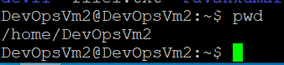

“ls” :- Use the **"ls"** command to know what files are in the directory you are in.

You can see all the hidden files by using the command **“ls -a”**.

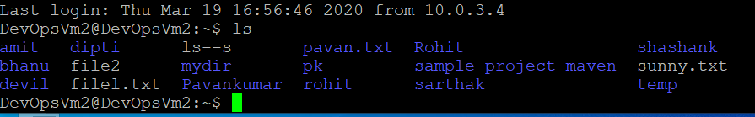

“cd” :- Use the **"cd"** command to go to a directory. For example, if you are in the

home folder, and you want to go to the downloads folder, then you can

type in **“cd Downloads”**. Remember, this command is case sensitive, and

you have to type in the name of the folder exactly as it is. But there is a

problem with these commands. Imagine you have a folder named

“Raspberry Pi”. In this case, when you type in **“cd Raspberry Pi”**, the shell

will take the second argument of the command as a different one, so you

will get an error saying that the directory does not exist. Here, you can use

a backward slash. That is, you can use **“cd Raspberry\ Pi”** in this case.

Spaces are denoted like this: If you just type **“cd”** and press enter, it takes

you to the home directory. To go back from a folder to the folder before

that, you can type “**cd** ..” . The two dots represent back.

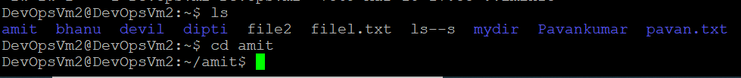

mkdir & rmdir:- Use the **mkdir** command when you need to create a folder or a

directory. For example, if you want to make a directory called

“DIY”, then you can type **“mkdir DIY**”. Remember, as told before,

if you want to create a directory named “DIY Hacking”, then you

can type “mkdir **DIY\ Hacking**”. Use **rmdir** to delete a directory.

But **rmdir** can only be used to delete an empty directory. To

delete a directory containing files, use **rm**.

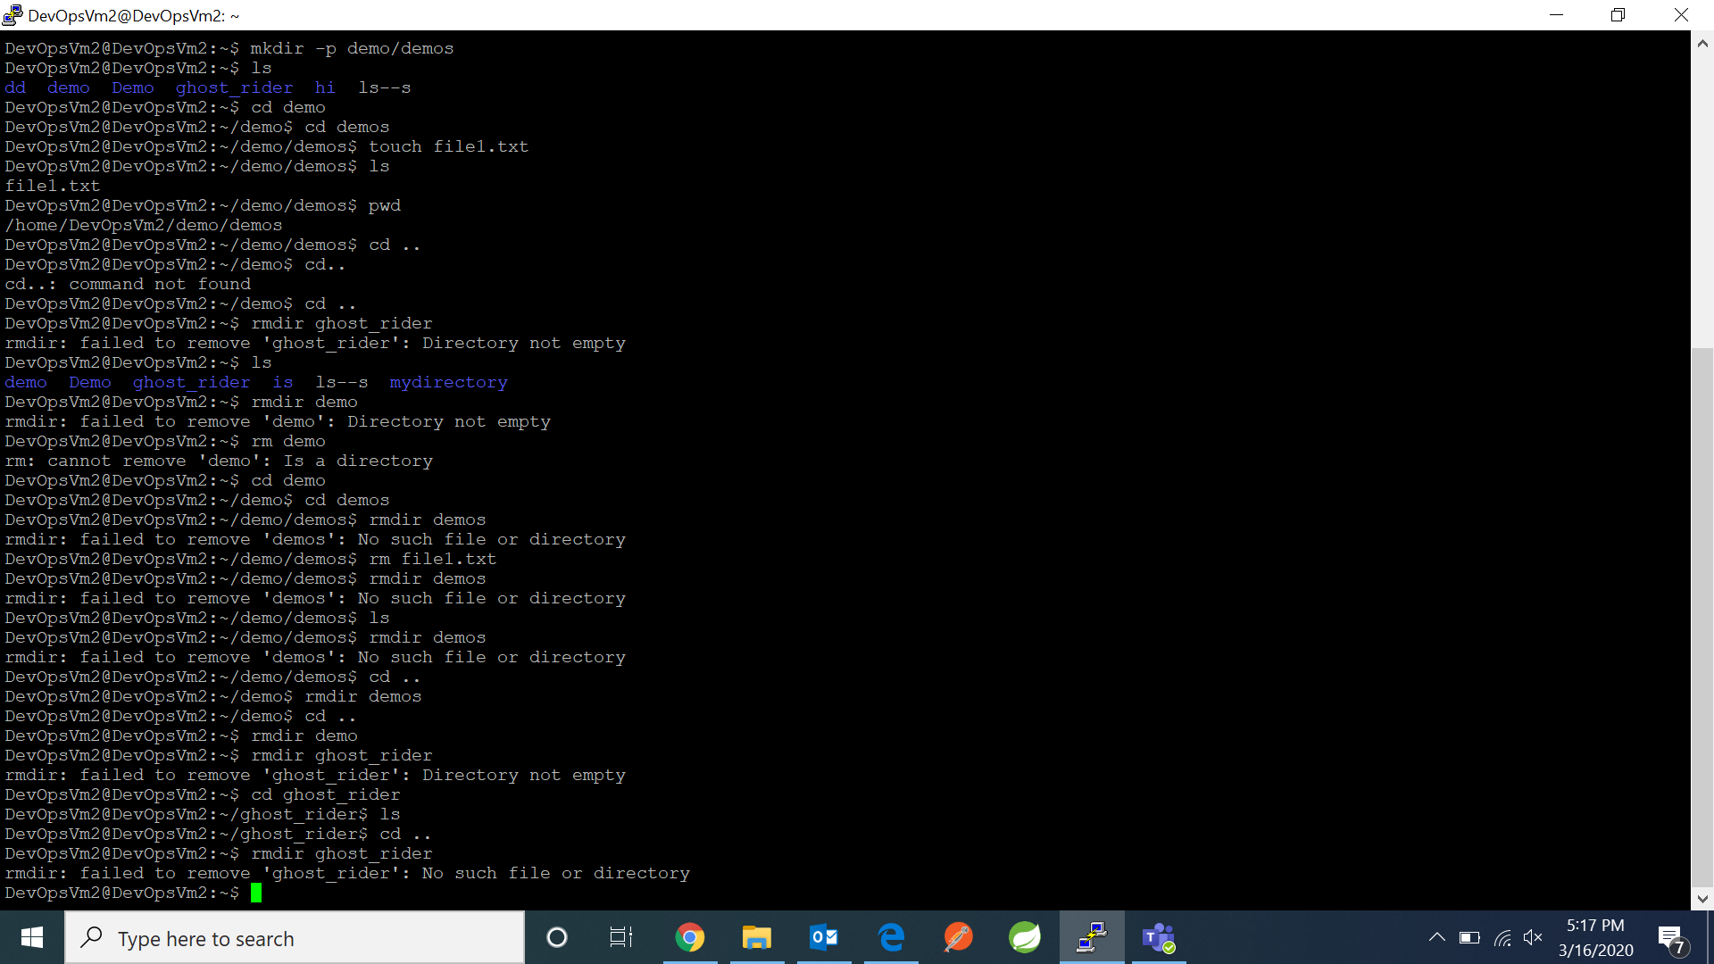

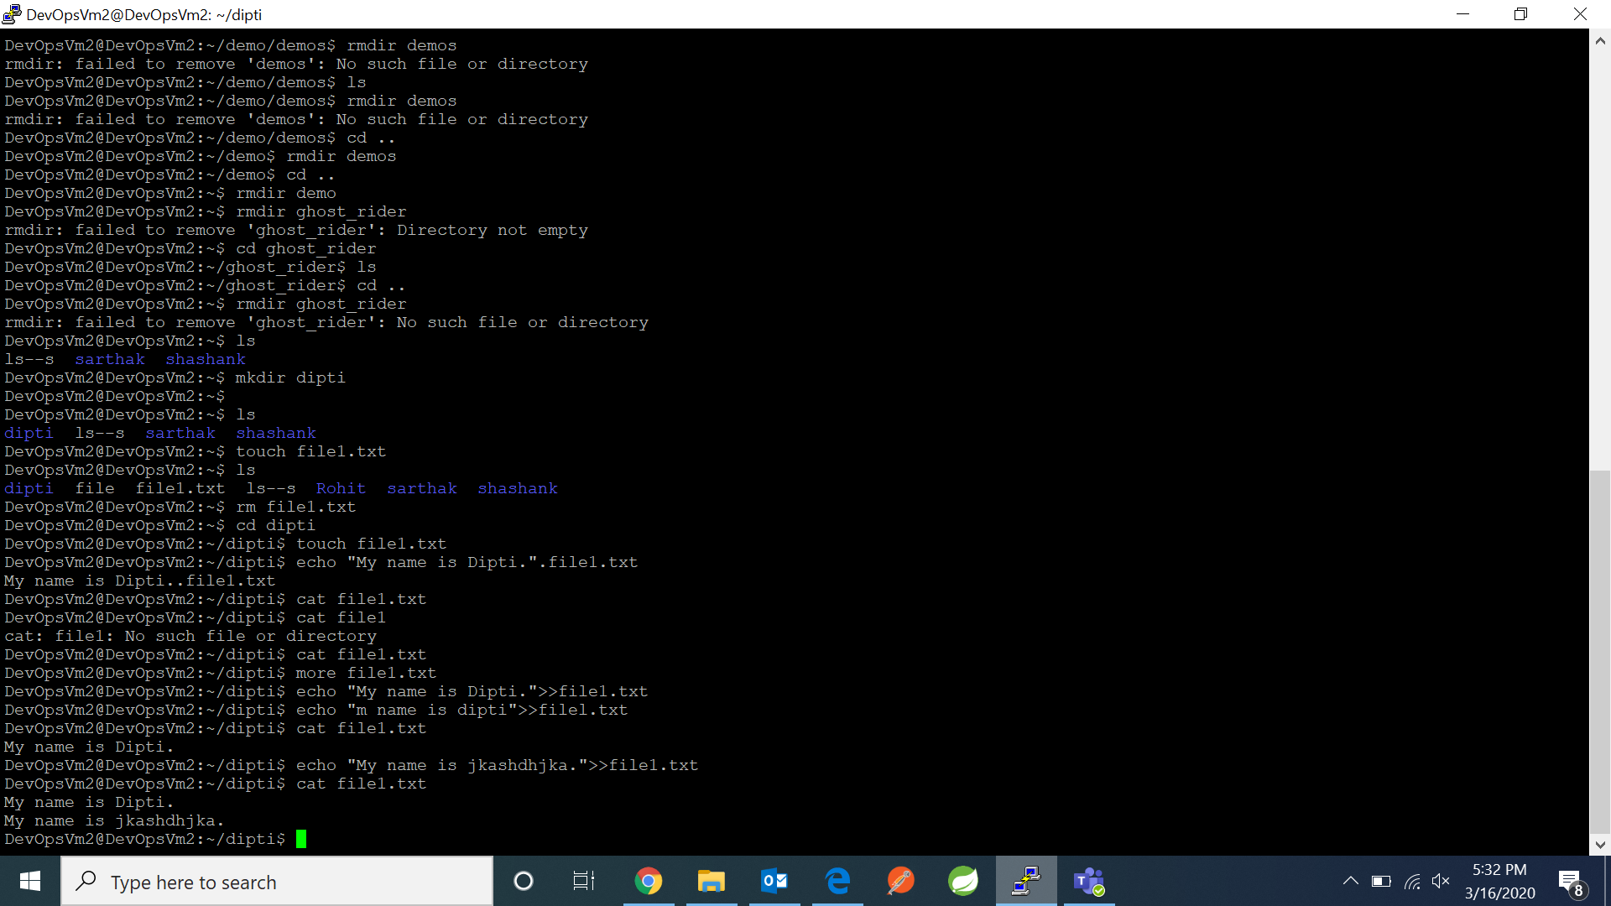

rm :- Use the **rm** command to delete files and directories.  Use "**rm -r**" to

delete just the directory. It deletes both the folder and the files it contains

when using only the **rm** command.

touch :- The**touch** command is used to create a file. It can be anything, from an

empty txt file to an empty zip file. For example, “**touch new.txt**”.

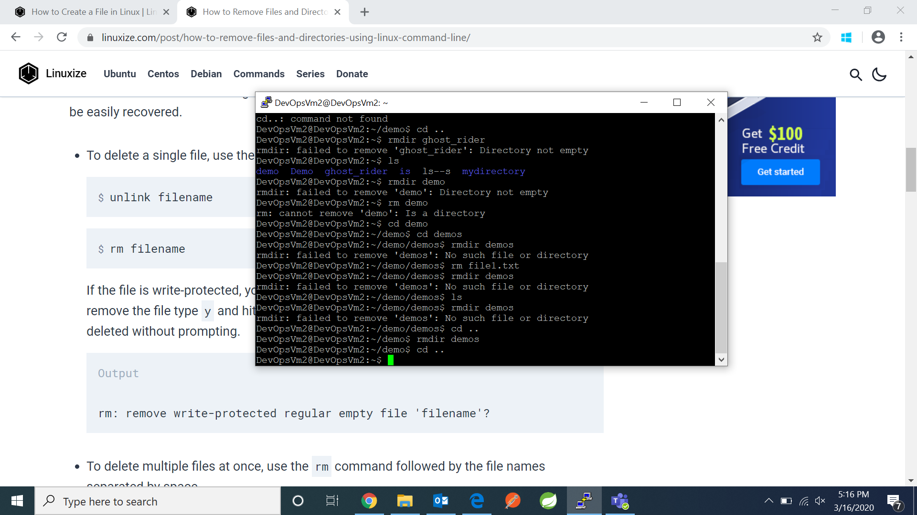

echo :- The**echo** command is used to write the data into the particular file.

For example, “**echo I am amit>>file.txt**”.

cat :- The**cat** command is used to read a file. It can be anything, from an

empty txt file to non-empty file. For example, “**cat file.txt**”.



cal :- The**cal** command is used to show the current calender.

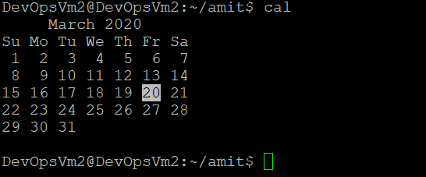

date :- The**date** command is used to show the current date.

